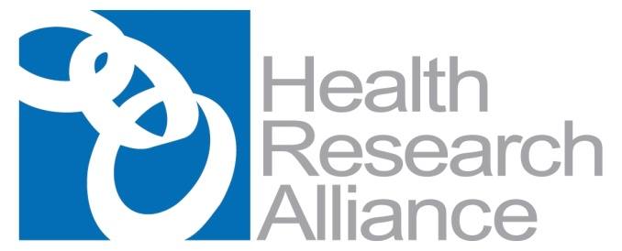
HEALTH RESEARCH ALLIANCE MEMBERS MEETING

March 30-31, 2020 – All sessions are virtual via Zoom

March 30 | Monday
12:00 – 2:00 PM ET | Using Platform-Based Tools to Measure Impact followed by Breakout session
Register to attend using this link. | As grantmakers, we often grapple with how to specifically demonstrate the impact of our research investment. Effectively explaining the return-on-investment from funding research is critical to our mission, as donors become increasingly interested in realizing the importance of their donations. This session will explore how platform-based tools can be used to visualize the impact of research funding. Guiding the session will be speakers who have successfully used such tools to tell their impact stories. Speakers will share the results of their work, while also discussing how they achieved the creation of deliverables to share with donors, their Boards, and/or the public. Likewise, they will also share their experiences and challenges that accompany the execution of such projects.  Moderator  Shannon Gallagher-Colombo, PhD  Associate Director, Corporate Alliances | American Association for Cancer Research  Presenter  Jocelyn LeBlanc, PhD  Research, Data and Impact Manager | Association of Medical Research Charities  Member Speaker  Kristen Mueller, PhD  Senior Director, Scientific Program | Melanoma Research Alliance
2:30 – 4:00 PM ET | Venture Philanthropy: Untapped Potential or Unintended Consequences? Exploring Venture Capital Approaches in the Philanthropic Space
Register to attend using this link. | Venture philanthropy does not come without its fair share of controversy. It remains a challenge for nonprofits, philanthropists, patients, start-ups and the general public to determine how – and if – we should combine philanthropy and for-profit strategies, even if the goal is to advance an organization’s mission as quickly as possible. Though venture philanthropy may have the potential to affect the pace of delivery of new treatments and translational research, there remain many considerations and challenges to choosing and implementing the most effective venture philanthropy model, including requirements for tracking grants and negotiating return of capital while staying true to the organization’s charitable purpose. This session will feature an overview presentation on how to navigate the options available within the venture philanthropy space, and then will have a moderated discussion and debate among several organizations that have applied these tools in unique ways within their grant-making portfolio. We will hear about their decision processes that led to the development of their approaches, how their venture philanthropy is structured, and successes and challenges with their approaches.  Moderator  Anne Hultgren, PhD  Executive Director | Arnold and Mabel Beckman Foundation  Presenters  Lisa Richter, MBA  Co-Founder and Managing Partner | Aviva Capital  Marco Baptista, PhD  Director, Research Programs | Michael J. Fox Foundation  Jill O’Donnell-Tormey, PhD  CEO and Director of Scientific Affairs | Cancer Research Institute  Jason Menzo  Chief Operating Officer | Foundation Fighting Blindness

March 31 | Tuesday
12:00 – 2:00 PM ET | RFA Development and Marketing & Open Mic
Register to attend using this link. | In this session, we will explore best practices for RFA development for new scientific areas, and marketing existing and new RFAs. In particular, speakers will discuss how to get input from innovators in a field new to the funder for a new RFA, key elements of a well-written RFA, and novel ideas for marketing your RFA to both traditional and expanded audiences. We will also examine this topic from the viewpoint of diversity and how RFAs can be written and marketed to ensure that underrepresented groups are reached and feel encouraged to participate.  Moderator  Anja Armache, PhD  Scientific Director | Damon Runyon Charitable Foundation  Presenter  Stephanie Endy, MA  Assoc. Vice President for Research | Office of Research Administration | Case Western Reserve University  Member Speakers  Michele Cleary, PhD  Chief Executive Officer | Mark Foundation for Cancer Research  Carole Wegner, PhD, HCLD  Senior Vice President, Research and Grants Administration | The V Foundation
2:30 – 4:30 PM ET | Patient Engagement & Breakout
Register to attend using this link. | This session will focus on the strengthening trend of incorporating the patient voice and values into funded research efforts. Patients are invited to be involved in various steps along the project-funding continuum: from engaging in setting research priorities, evaluating research proposals, participating in the research team, and receiving updates and feedback during their participation in clinical research projects.  This session will be followed by a breakout session. The committee will survey the membership before and present the survey results at the beginning of the breakout. During the breakout more HRA members will be able to share info on their programs in more detail. Plus have the researcher and the patient advocate at the breakout.  Moderator  Krissa Smith, PhD  Director, Research Programs | Susan G. Komen  Presenters  Michelle Johnston-Fleece, MPH  Senior Program Officer | Patient-Centered Outcomes Research Institute  Alana Welm, PhD  Professor of Oncological Sciences | University of Utah School of Medicine  Sandi Spivey, MBA  Advocate | Metastatic Breast Cancer Patient Advisory Council  Member Speakers  Diana Shineman, PhD  Vice President of Research and Medical Programs | Tourette Association of America  Dean Frohlich, PhD  Scientific Review Officer | Conquer Cancer, the ASCO Foundation  Angela McCarty, MS  Associate Manager, Peer Review | American Heart Association  Glendon Zinser, PhD  Scientific Grants Manager | Susan G. Komen

