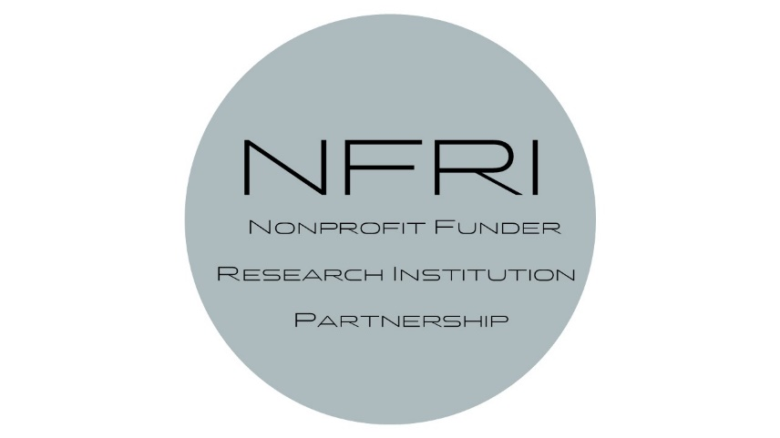
v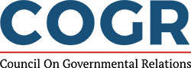

Agenda for VIRTUAL Meetings
April 23rd, 2020

11:30 am-1:00pm Research Project Support Costs Working Group REGISTER HERE
- Chairs: Diane Bovenkamp and Cindy Hope
- Subgroups
  - Toolkit Patrick Clark and Heather Moore
  - Examples Diane Bovenkamp and Nancy Lewis
  - Education Maryrose Franko and Dave Kennedy

1:30pm-3:00pm Streamlining Working Group REGISTER HERE
- Chairs: Andrew Smith and Vivian Holmes
- Subgroups
  - Application Sara Strickland and Stephanie Endy
  - Contracting Missy Peloso and Whitney Steen
  - Financial Reporting Charles Greer and Mehvish Khan

3:30pm-5:00pm IP/Tech Transfer Working Group REGISTER HERE
- Chairs: Jilda Garton, Amy Laster, and Fred Reinhart
- Subgroups
  - Royalty Sharing Jackie Hausman, Fred Reinhart, and John Ritter
  - Control of Licensing Jeremy Nelson
  - Patient Access Amy Laster and Felice Lu
  - Background/Definition of IP Alex Albinak and Kevin Wozniak

Each Working Group presentation will end with a discussion of next steps
- What is left to do (by whom) before finalizing documents?
- How do we market the resources (broaden the coalition)?
- How can we capture when things are/aren’t working?
- How can we incorporate then disseminate feedback?
- When and how do we bring our researchers into the conversation?

Hopefully, we will schedule another in-person NFRI Workshop where we unveil these resources to a much broader audience of personnel from research institutions and funders.

